26th August 2020
Temperature checking
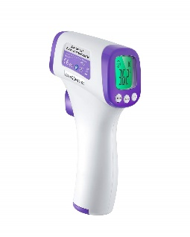
Dear Parent/Guardians,
As part of our plan to try and make the school as risk free as possible, we are anticipating in completing temperature checks on pupils and staff each day. Each classroom will have a temperature gun which is placed on the child’s forehead and takes their temperature. Any child with a high temperature will be sent home.
As a school, we can never guarantee a complete risk free environment. However, we are doing everything in our power to ensure that protocols are in place.
If you do not permit your child to be temperature checked, please let me know.

Thank you in advance for your understanding,
Avril Wilson
Principal

